Function with default parameters or optional parameters

What is default parameter?
A parameter given value at the time of defining function is called default parameter. These parameters do not require give/input value at the time of invoking function or calling function.

Syntax:
def function-name(param-name,param-name,param-name=value,param-name-value,..):
statement-1
statement-2

Example:
def fun1(a,b):
print("function with required parameters")
print(f'a={a},b={b}')

def fun2(x=None,y=None):
print("function with default/optional parameters")
print(f'x={x},y={y}')

fun1(100,200)
fun2()
fun2(10,20)
fun2(y=99)
fun2(88)

Output
function with required parameters
a=100,b=200
function with default/optional parameters
x=None,y=None
function with default/optional parameters
x=10,y=20
function with default/optional parameters
x=None,y=99
function with default/optional parameters
x=88,y=None

Example:
def drawline(ch="*",length=20):
for i in range(length):
print(ch,end='')
print()

#main
drawline()
print("PYTHON")
drawline("$")
print("PROGRAMMING LANGUAGE")
drawline(length=30)
print("HIGH LEVEL LANGUAGE")
drawline("@",30)

Output
********************
PYTHON
$$$$$$$$$$$$$$$$$$$$
PROGRAMMING LANGUAGE
******************************
HIGH LEVEL LANGUAGE
@@@@@@@@@@@@@@@@@@@@@@@@@@@@@@

Example:
def simple_interest(amt,t,rate=1.5):
si=(amt*t*rate)/100
return si

#Main
si1=simple_interest(9000,12)
print(si1)
si2=simple_interest(15000,24,2.0)
print(si2)

Output
1620.0
7200.0

Example of function with default or optional parameters

def sort_list(a,ascending=True):
if ascending:
for i in range(len(a)):
for j in range(len(a)-1):
if a[j]>a[j+1]:
a[j],a[j+1]=a[j+1],a[j]
else:
for i in range(len(a)):
for j in range(len(a)-1):
if a[j]<a[j+1]:
a[j],a[j+1]=a[j+1],a[j]

#Main
A=[8,5,3,2,4,1,7,6]
print(f'Before Sorting {A}')
sort_list(A)
print(f'After Sorting in Ascending Order {A}')
sort_list(A,False)
print(f'After Sorting in Descending Order {A}')

Output
Before Sorting [8, 5, 3, 2, 4, 1, 7, 6]
After Sorting in Ascending Order [1, 2, 3, 4, 5, 6, 7, 8]
After Sorting in Descending Order [8, 7, 6, 5, 4, 3, 2, 1]

Example:
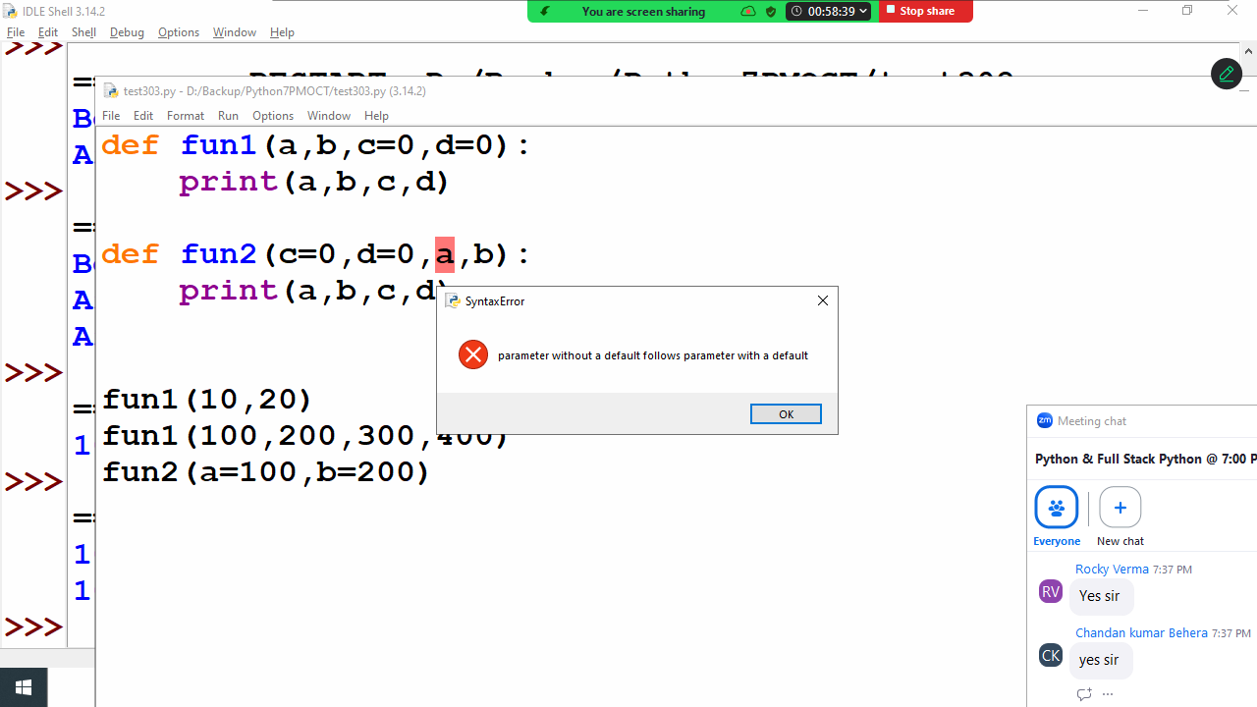
The above program generates syntax error because the order of defining required and default is, always required parameters follows default parameters.

Function with variable length parameters
Function with variable length parameter receives 0 or more values.
Python support 2 types of variable length parameters
- Variable length positional parameters
- Variable length keyword parameters

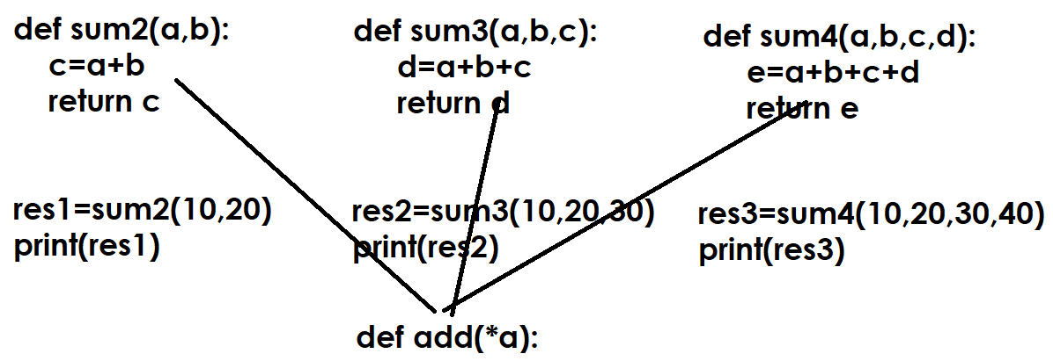

Variable length positional parameter
Variable length positional parameter is prefix with *
Variable length positional parameter is of type of tuple
This will organize data according to their position/index

Syntax:
def function-name(*param-name):
statement-1
statement-2

In application development a function is defined with variable length parameter if function required more than one value to perform operation.

Example  def fun1(*a):  print(a,type(a))  #Main  fun1()  fun1(10)  fun1(10,20)  fun1(10,20,30,40,50)  fun1(1,"naresh",1.5) | Output  () <class 'tuple'>  (10,) <class 'tuple'>  (10, 20) <class 'tuple'>  (10, 20, 30, 40, 50) <class 'tuple'>  (1, 'naresh', 1.5) <class 'tuple'>
Example:  def add_num(*values):  s=0  for value in values:  s=s+value  return s  #Main  res1=add_num()  print(res1)  res2=add_num(10,20)  print(res2)  res3=add_num(10,20,30,40,50,1.5,2.5)  print(res3) | Output  0  30  154.0
Example  def maximum(*values):  for i in range(len(values)):  if i==0:  max_value=values[0]  elif values[i]>max_value:  max_value=values[i]  if len(values)==0:  return None  else:  return max_value  #Main  res1=maximum()  print(res1)  res2=maximum(10)  print(res2)  res3=maximum(40,60,70)  print(res3) | Output  None  10  70

Variable length keyword arguments

Variable length keyword parameters are prefix with **
Variable length keyword parameter is of type dictionary
Variable length keyword parameter receives data as key and value pair.

Syntax:
def function-name(**parameter-name):
statement-1
statement-2

